**Step-by-Step Guide for MongoDB Backup to EBS Volume**

**1. Prerequisites**

* **MongoDB Installed**: Ensure MongoDB is installed on your EC2 instance.
* **EBS Volume Attached**: Ensure an EBS volume is attached to your EC2 instance and properly formatted.

**2. Install MongoDB Tools**

MongoDB tools like mongodump and mongorestore are needed for backup and restoration. Install them with the following command:

bash

sudo apt-get install mongodb-org-tools

**3. Mount EBS Volume**

First, format your EBS volume if it hasn't been formatted yet. Replace /dev/xvdk with your actual device name:

bash

sudo mkfs -t ext4 /dev/xvdk

Next, create a mount point and mount the EBS volume:

bash

sudo mkdir -p /mnt/ebs_volume

sudo mount /dev/xvdk /mnt/ebs_volume

**4. Create Backup Directory**

Create a directory where MongoDB backups will be stored temporarily before moving to the EBS volume:

bash

sudo mkdir -p /var/backups/mongo

**5. Create Backup Script**

Create a script named mongo_backup.sh and make it executable. This script will handle the backup process.

bash

sudo nano /usr/local/bin/mongo_backup.sh

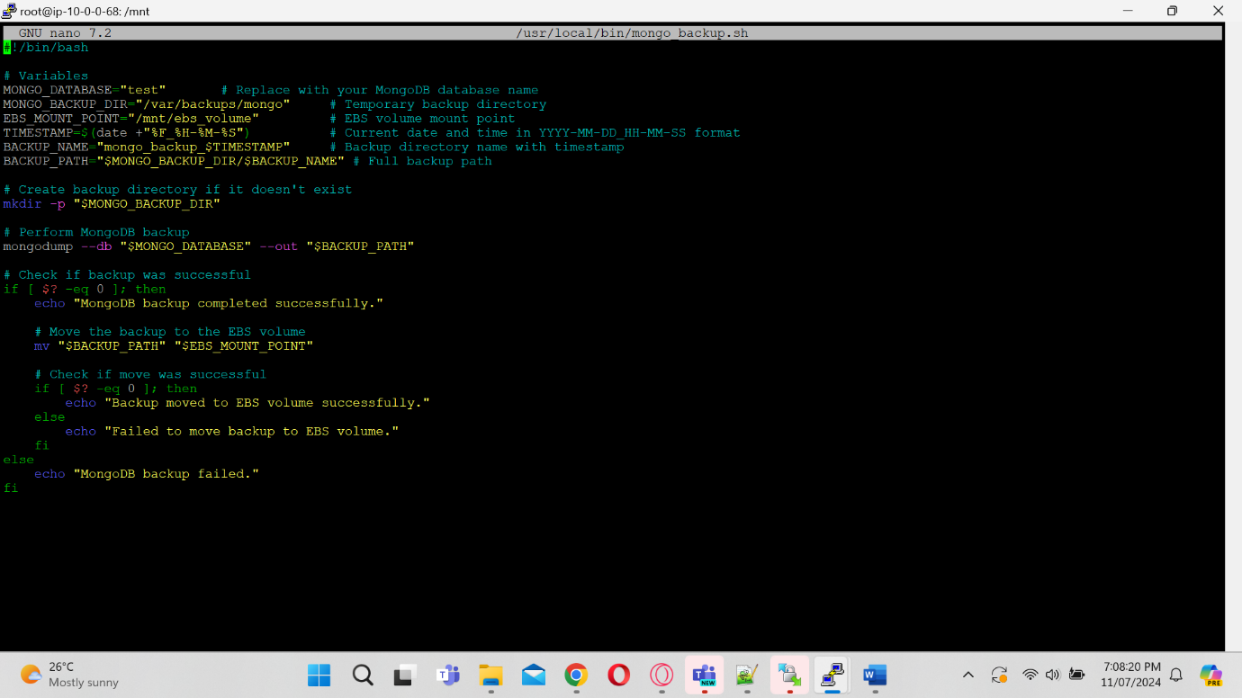

Make the script executable:

bash

sudo chmod +x /usr/local/bin/mongo_backup.sh

**6. Schedule Automatic Backups with Cron**

Edit the crontab to schedule the backup script to run automatically every 30 minutes:

bash

sudo crontab -e

Add the following line to the crontab file:

bash

*/30 * * * * /usr/local/bin/mongo_backup.sh >> /var/log/mongo_backup.log 2>&1

This will run the backup script every 30 minutes and log the output to /var/log/mongo_backup.log.

**7. Verify Backup Setup**

Manually run the backup script to ensure it works as expected:

bash

sudo /usr/local/bin/mongo_backup.sh

Check the EBS volume mount point to verify that the backup files have been moved successfully.

**Summary**

This setup involves:

* Installing necessary MongoDB tools.
* Mounting an EBS volume for storing backups.
* Creating a directory for temporary backup storage.
* Writing a shell script to perform the MongoDB backup and move it to the EBS volume.
* Scheduling the backup script to run automatically every 30 minutes using cron.